**Fatima Jinnah Women University**

Department of Software Engineering

**LAB 5**

**Name:** Raifa Khalid

**Reg. no:** 2020-BSE-024

**Section:** A

**Semester:** Fourth

**Course:** Data Base (LAB)

TASKS

1. **Write a query to display the current date.**

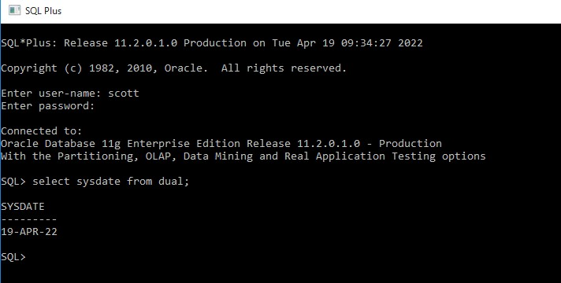

1. **For each employee, display the employee ID number, employee name, salary and salary increased by 15% and expressed as whole number. Label the column New Salary.**

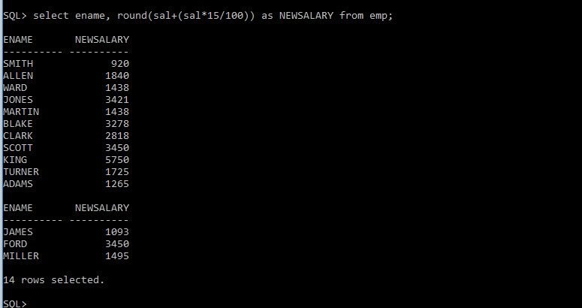

1. **Modify the above query to add a column that subtracts the old salary from the new salary. Label the Column Increase.**

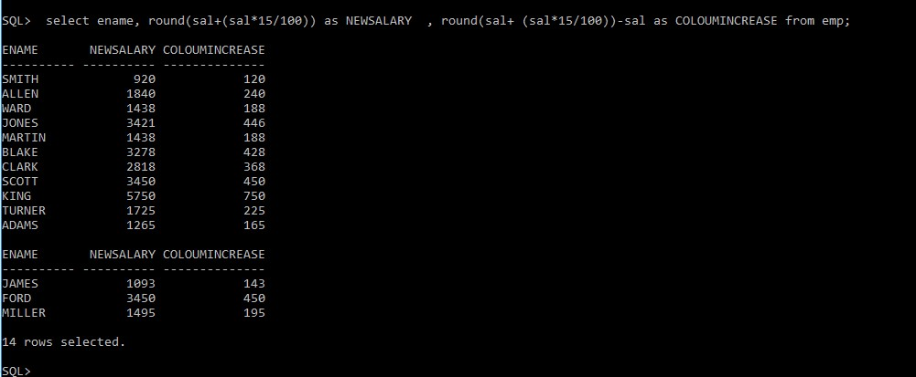

1. **Write a query that displays the employee’s names with the first letter capitalize and all other letters lowercase and length of the names, for all employees whose name start with J, A or M. Give each column an appropriate label. Sort the results by employees’ name.**

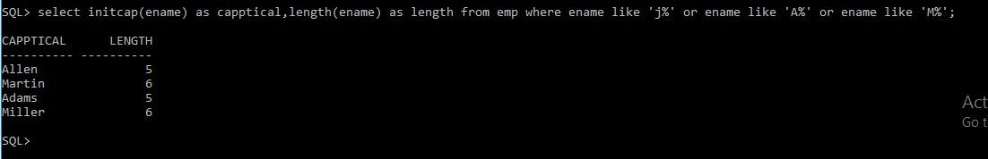

1. **For each employee, display the employee name and calculate the number of months between today and a day the employee was hired. Label the column MONTHS_WORKED. Order your results by the number of months employed. Round the number of results up to closest whole number**.

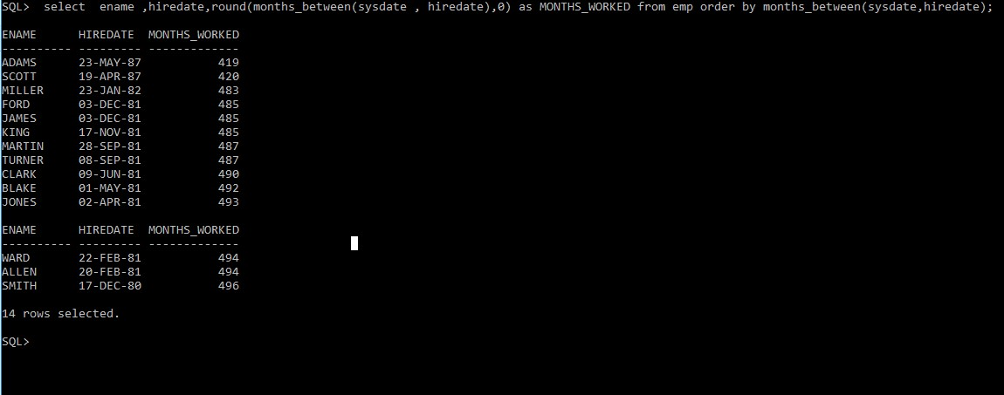

1. **Write a query that produces the following for each employee:**

**Employee name, earns salary monthly but wants 3 times salary. Label the column Dream Salaries.**

**//Salary should be in this format $99,999.00**

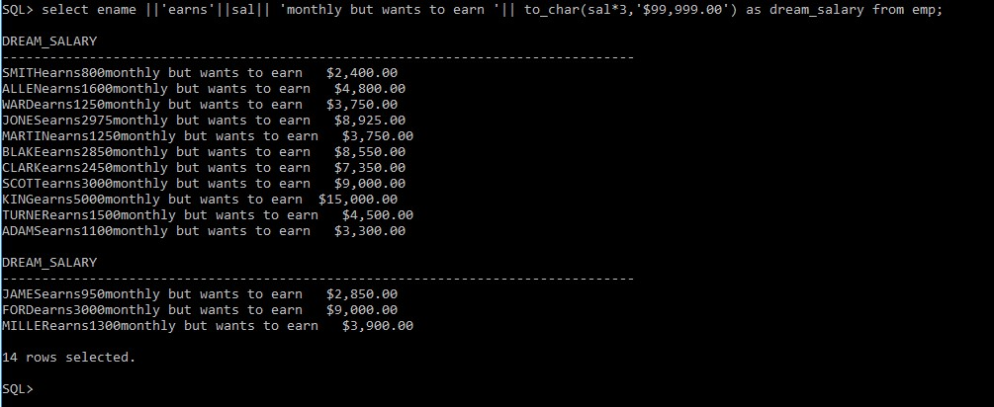

1. **Create a query to display the employee name and salary of all employees. Format the salary to be 15 characters long, left-padded with $. Label the column SALARY.**

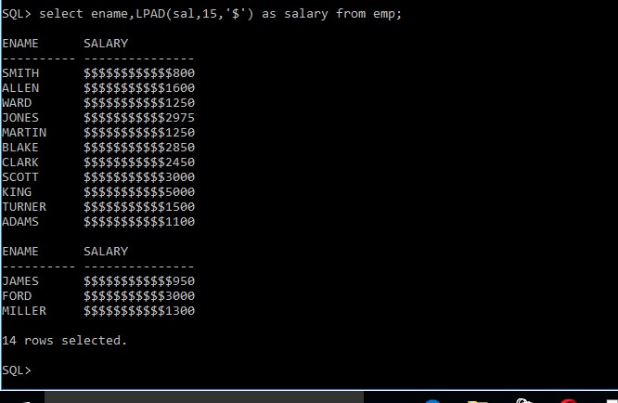

1. **Display each employee name, hiredate and salary review date, which is the first Monday after six months of service. Label the column REVIEW. Format the dates to appear similar to “Monday, the Thirty-first of July, 2000”.**

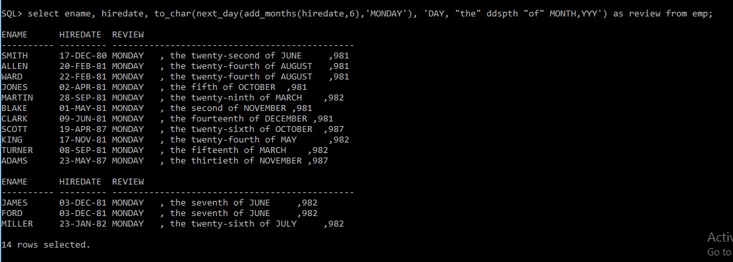

1. **Display the employee name, hiredate, and day of the week on which the employee started. Label the column DAY. Order the results by the day started with Monday.**

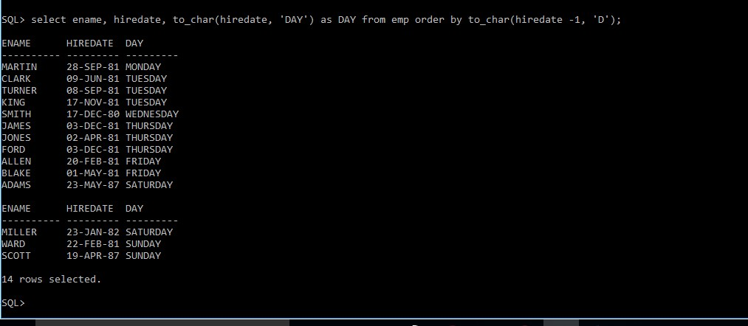

1. **Create a query that displays the employees’ names and indicates the amounts of their salaries through asterisks. Each asterisk signifies a hundred dollars. Sort the data in descending order of salary.**

**Label the column EMPLOYEE_AND_THEIR_SALARIES.**

